**Project Objectives :**

The main objective of the this project is to build a model to predict weather the website link given by the user is fake or real.

By the end of the project we will,

1. You’ll be able to understand the problem to classify if it is a regression or a classification kind of problem.
2. You will be able to know how to pre-process/clean the data using different data pre-processing techniques.
3. Applying different algorithms according to the dataset
4. You will be able to know how to evaluate the model.
5. You will be able to build web applications using the Flask framework.

**Project Flow :**

* The user interacts with the UI (User Interface) to enter the input features
* Entered input features are analysed by the model which is integrated
* Once the model analyzed the input, the prediction is showcased on the UI
* The result is displayed in the UI
* A decision is given to the user whether to use the website or not
* To accomplish this, we have to complete all the activities and tasks listed below
* Download the dataset.
* Preprocess or clean the data.
* Analyze the pre-processed data.
* Train the machine with preprocessed data using an appropriate machine learning algorithm.
* Save the model and its dependencies.
* Build a Web application using Flask that integrates with the model built.

**Pre – Requisites :**

*Step 1 :**To install the anaconda navigator*



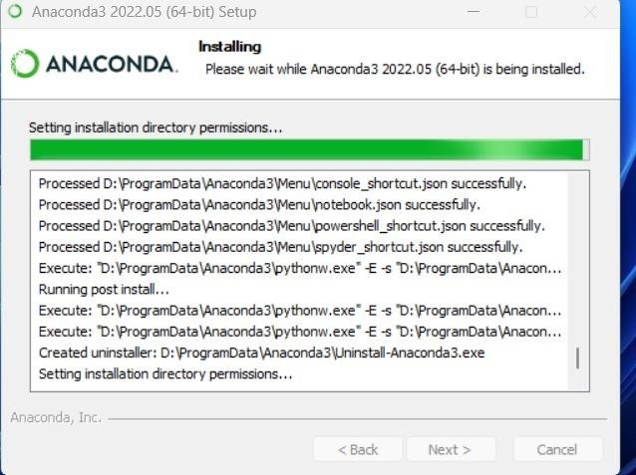

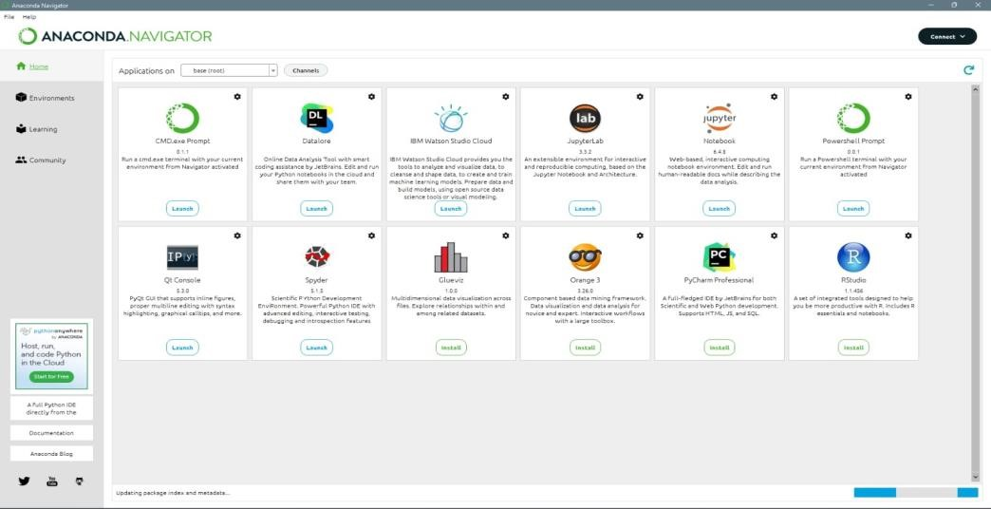

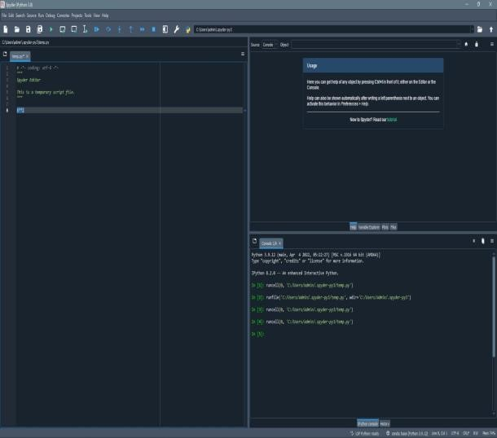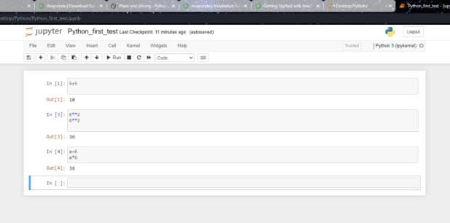

*Step 2 : To install the Following packages*

* *Sklearn – pip install scikit-learn*
* *Numpy – pip install numpy*
* *Pandas – pip install pandas*
* *Matplotlib – pip install matplotlib*
* *Flask – pip install Flask*

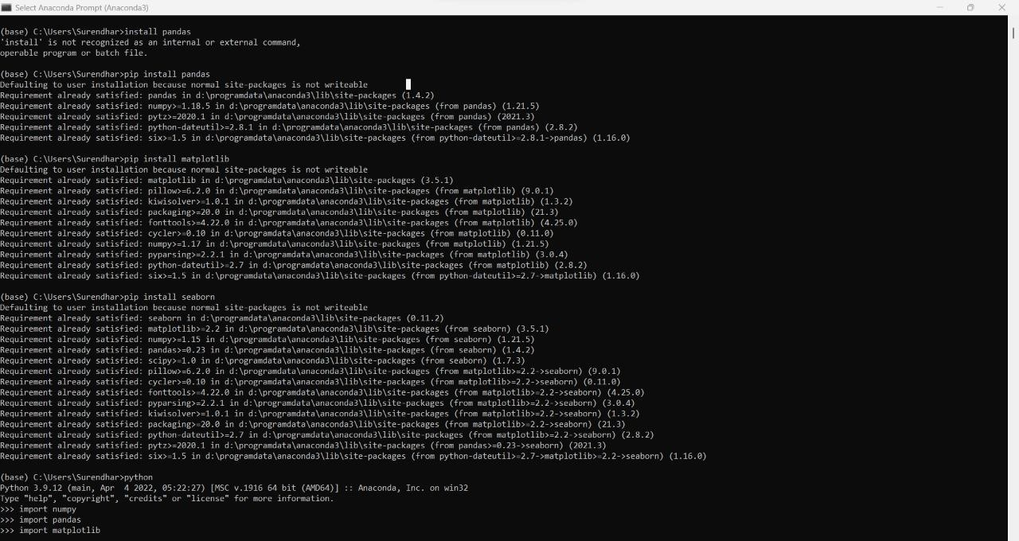

**Prior Knowledge :**

1. Supervised and unsupervised learning

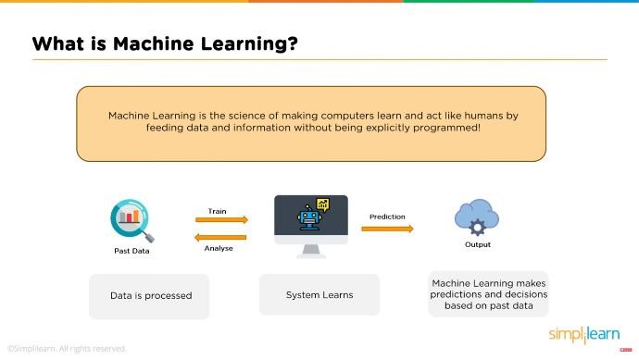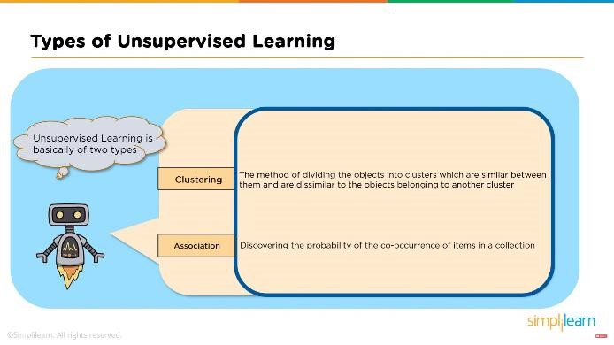

1. Regression Classification and Clustering

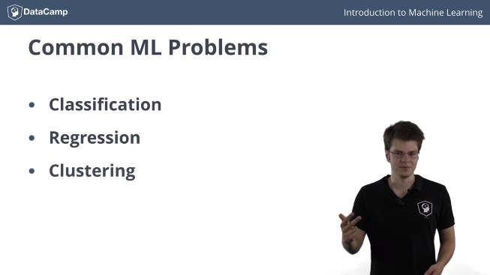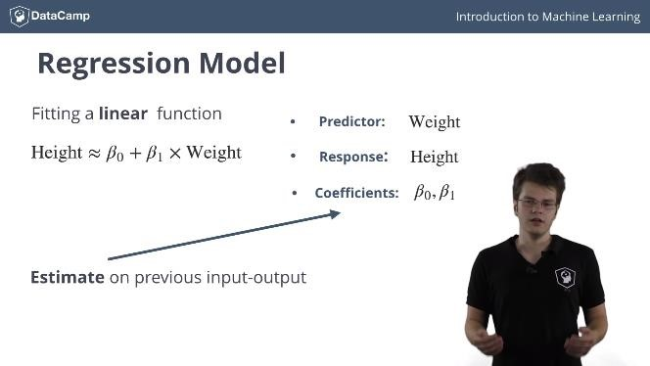

1. Random Forest Regressor

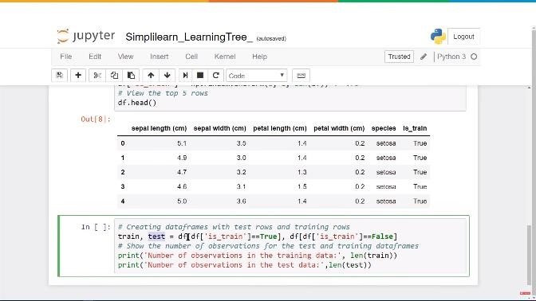

1. Flask :

